# Naive Bayes

Study the [Naive Bayes](https://scikit-learn.org/stable/modules/generated/sklearn.naive_bayes.MultinomialNB.html) and [Sparse Matrix](https://docs.scipy.org/doc/scipy/reference/generated/scipy.sparse.csr_matrix.html) classes. For the messages dataset build classifier. Plot [ROC curve](https://scikit-learn.org/stable/modules/generated/sklearn.metrics.roc_curve.html) and output [confusion matrix](https://scikit-learn.org/stable/modules/generated/sklearn.metrics.confusion_matrix.html). You can use this example to read messages.

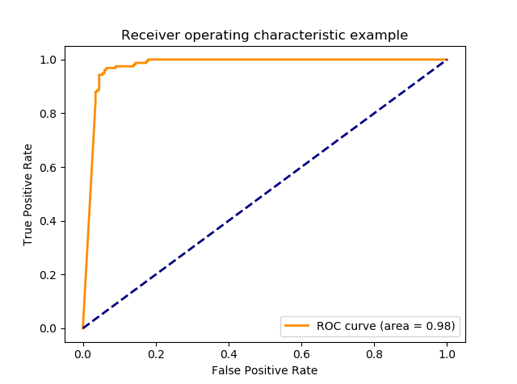

Consider the following decision rule:

|  |  |
| --- | --- |
|  | **def** get_class(spam_prob):  **if** spam_prob < 0.5:  **return** "legit"  **else**:  **return** "spam" |

Try to modify it such that no one legit message will be classified as spam but accuracy will be as high as possible